Feature Description

One of our biggest feature is that the Mozart music game is oriented to all age groups. Since people in the society are of different ages, having different cognitions and attitudes toward things, say game, music, life, etc. As a result, people’s demands for a game varies. Under this circumstance, a game performs well if it can adjust to various demands.

In order to elucidate our game’s advantage in all-age-adapt, here we provide 4 typical user stories representing 4 use cases.

Use Case 1

Consider a kindergarten girl whose name is A. She is 6 years old and of the age to learn about the world. Since classic music is thought to be beneficial to people out of various music styles, A’s mother want to cultivate her interest for it using Mozart game. As A is too young to understand Mozart’s career, her mother can choose “Replay” mode to cultivate her sense of rhythm, or choose “Enjoy” mode to teach her knowledge of classical music.

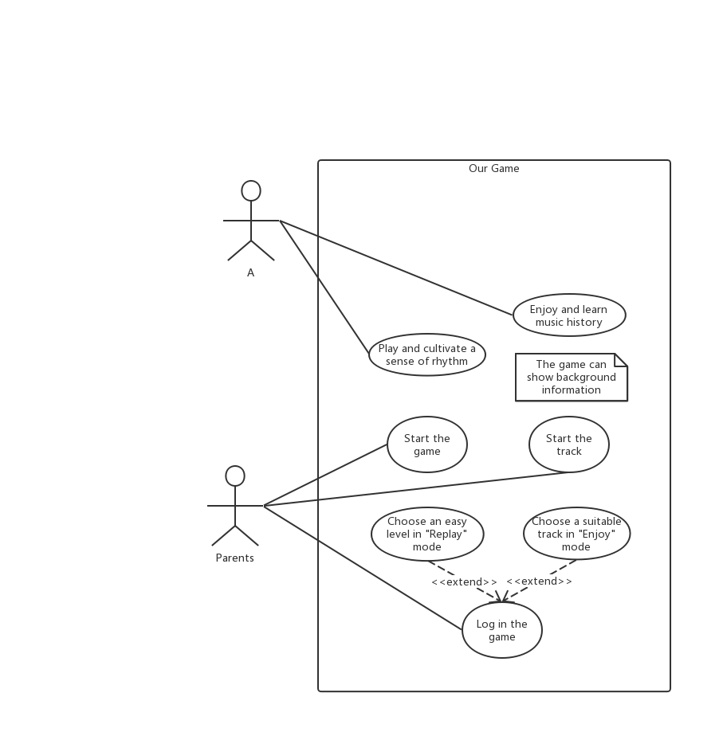

Use Case 2

Consider a middle school boy whose name is B. He is 16 years old with heavy study load and he wants to play games in his spare time. As a middle-school-age boy is able to play with complex games and is in an important period to learn things. B mainly has 2 choices, one is to upgrade and learn experience as a development game, gaining fun and sense of achievement, the other is to have a deeper knowledge of Mozart.

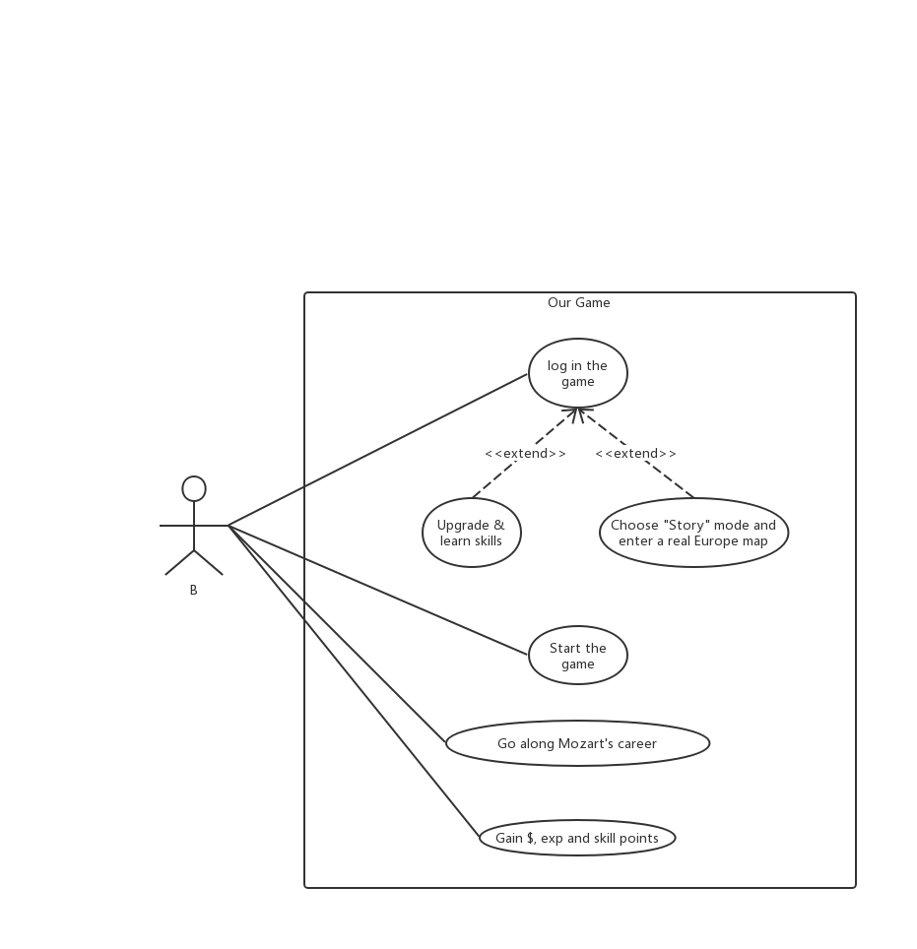

Use Case 3

Consider a mid-year man whose name is C. He is 30 years old and is a busy office clerk with heavy work load. Sometimes, he wants to relax by listening to some music. So he can choose “Enjoy” mode to get relaxed. But sometimes, he wants to do some challenging things to let out his pressure. So he can choose “Zen” mode to challenge Boss.

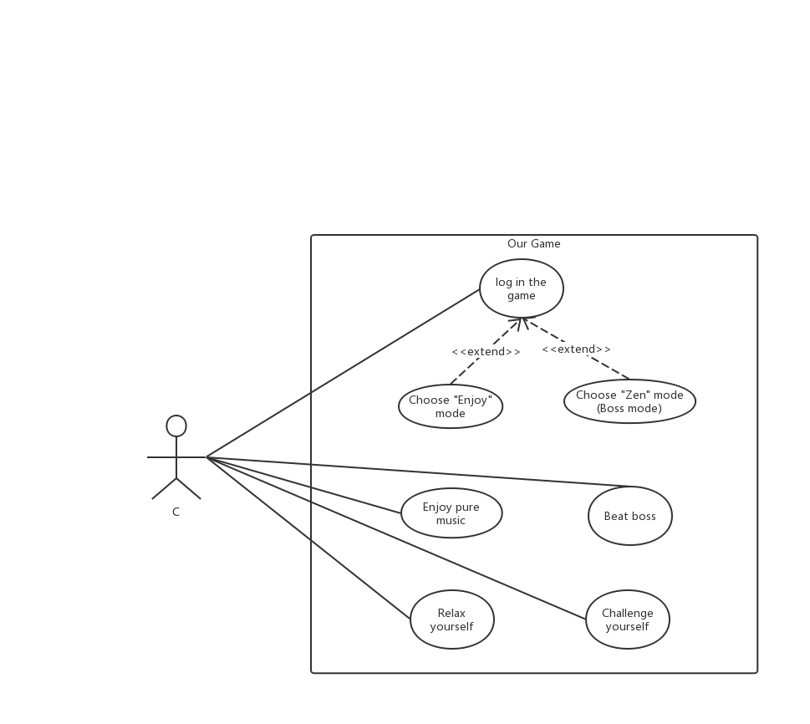

Use case 4

Consider an elderly woman whose name is D. She is 65 years and gest retired. During these days, her children is worried about her health. Since D’s memory is decreasing, she might suffer from Alzheimer which is a horrible disease. Under these circumstance, her children let her play Mozart game to help her prevent Alzheimer since this is a fast-paced game which can improve people’s responsiveness. Also, she can choose “Enjoy” mode to enjoy music.